30.68: (a) steady state has been reached, for all practical purposes.
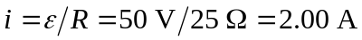
The upper limit of the energy that the capacitor can get is the energy stored in the inductor initially.
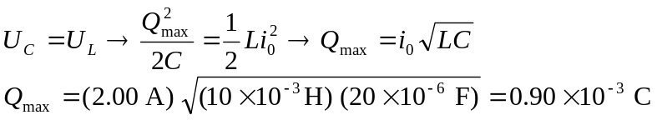
(b) Eventually all the energy in the inductor is dissipated as heat in the resistor.
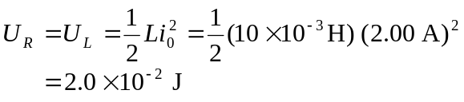
(c)
